USER PERSONAS FOR AN ONLINE LEARNING PLATFORM

Introduction
A user persona is a simple profile representing a typical user of a product. For an online learning platform, personas help designers understand who uses the platform, what they want to achieve, how they study, and what problems they face. These insights help create a clear, useful, and user-friendly learning experience.

2. Why User Personas Are Important
- They help the design team understand target learners.
- They identify the main goals users want to achieve.
- They show common learning habits and behaviors.
- They highlight pain points that can reduce satisfaction.
- They help designers select useful features.
- They reduce design decisions based only on assumptions.
- They keep the design focused on real user needs.

3. Primary Persona – College Student
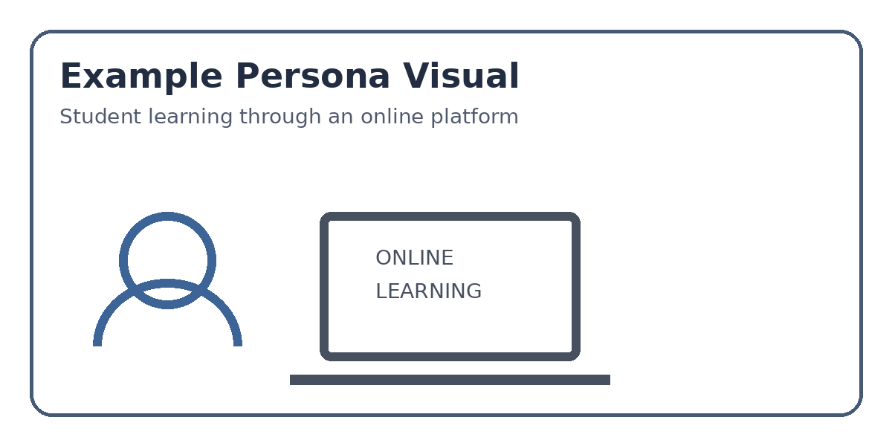

Name | Akshatha – The Busy Learner
Age | 19 years
Role | College student
Learning Needs | Course lessons, exam preparation, skill development
Technology | Smartphone and laptop
Akshatha is a college student who uses online courses outside classroom hours. She prefers short lessons, simple navigation, and learning materials that can be accessed whenever she has free time.
PERSONA DETAILS: GOALS, BEHAVIORS & PAIN POINTS

4. Persona 1 – Akshatha, the Busy Learner

Goals
- Complete online courses and improve academic performance.
- Learn new technical and professional skills.
- Watch lessons at a convenient time and place.
- Track course progress and finish learning goals.
- Receive certificates after completing useful courses.

Behaviors
- Studies in short sessions between college activities.
- Uses a smartphone for quick lessons and a laptop for assignments.
- Searches for beginner-friendly explanations before advanced topics.
- Saves useful lessons for later revision.
- Checks ratings, reviews, and course duration before starting.
- Prefers videos with captions, notes, quizzes, and examples.
- May stop learning when a course feels too long or difficult.

Pain Points
- Too many courses make it difficult to choose the right one.
- Long videos can reduce concentration.
- Complicated menus make lessons difficult to find.
- Slow loading or poor mobile performance interrupts learning.
- Unclear progress information makes the next step confusing.
- Difficult language without examples can discourage beginners.
- Too many notifications can become distracting.

5. Design Needs Based on Persona 1
- Provide a clear search bar and course categories.
- Show course duration, level, rating, and certificate information.
- Use a simple dashboard with visible progress.
- Allow users to save selected learning materials.
- Include captions, transcripts, quizzes, and practice activities.
- Keep navigation consistent across mobile and desktop.
- Use reminders carefully so they support learning without becoming annoying.
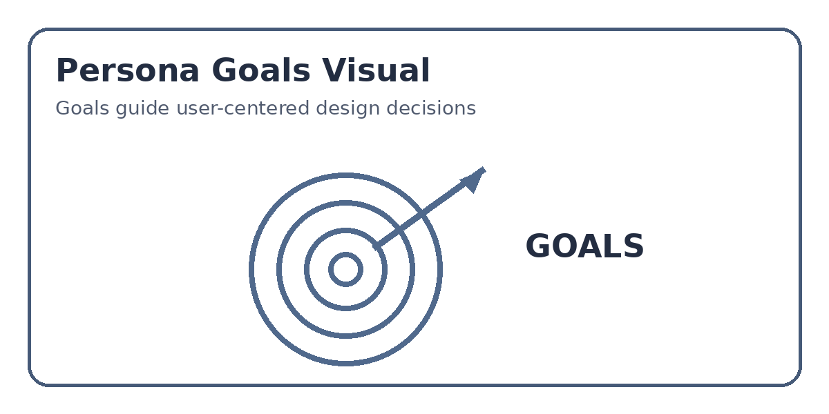
SECONDARY PERSONA & UX INSIGHTS

6. Persona 2 – Working Professional

Name | Rahul – The Career Builder
Age | 27 years
Role | Working professional
Goal | Improve job skills and career opportunities
Preferred Learning | Short courses, practical projects, certificates

Goals
- Learn skills directly useful for work.
- Complete courses without affecting office responsibilities.
- Build a stronger resume and professional profile.
- Practice concepts through real-world projects.
- Earn useful certificates.

Behaviors
- Studies mainly during evenings, weekends, or travel time.
- Prefers short videos and practical demonstrations.
- Compares courses before enrolling.
- Returns to difficult topics for revision.
- Uses progress tracking to manage limited study time.

Pain Points
- Limited free time makes long courses difficult to complete.
- Some courses contain too much theory and little practical work.
- Unclear course outcomes make course selection difficult.
- Poor mobile support is inconvenient during travel.
- Certificates may not clearly show what skills were learned.

7. Key UX Insights
- Design the platform around learner goals, not only features.
- Make course discovery fast with search, filters, and clear descriptions.
- Use progress indicators to motivate users and show the next step.
- Break large courses into smaller lessons.
- Provide practical activities, quizzes, projects, and examples.
- Make the platform responsive on both mobile and desktop.
- Keep the interface simple, accessible, consistent, and beginner-friendly.

8. Conclusion
User personas help an online learning platform understand different types of learners. Ananya needs flexible, simple, and engaging learning because she balances college activities with online study. Rahul needs short, practical, career-focused learning because he has limited time. By considering their goals, behaviors, and pain points, designers can create a platform that is useful, easy to navigate, and satisfying to use.

